Infosys Springboard Virtual Internship 6.0 Completion Report

**Team Details:**

Batch: A

Start Date: 10-Oct-25

Names:

|  |  |
| --- | --- |
| **S.No.** | **Name** |
| 1 | Aditya Gadilkar |
| 2 | Diya Lodha |
| 3 | Patnaikuni Sai Likhita |
| 4 | Sahithi Akula |
| 5 | Adarsh Rout |
| 6 | Neha Maram |

Internship Duration: 10 Weeks

1. **Project Title**

**HotelRevAI AI-Driven Revenue Analysis for Hotels**

1. **Project Objective**

The primary objective of the **HotelRevAI – AI-Driven Revenue Analysis for Hotels** project is to design and implement an intelligent analytics system that enables hotels to monitor, analyze, and optimize their revenue and occupancy performance using data-driven insights.

The specific objectives of the project are as follows:

* + - To collect, integrate, and structure hotel booking, customer, and room-level data into a well-defined analytical data model suitable for reporting and analysis.
    - To calculate and analyze key hospitality performance indicators such as **Occupancy Rate, Average Daily Rate (ADR), and Revenue per Available Room (RevPAR)** across different time periods.
    - To study guest behavior patterns by analyzing booking sources, guest types, nationality, length of stay, and spending behavior.
    - To identify customer segments such as first-time guests, repeat customers, and high-value guests using clustering techniques.
    - To analyze booking trends, cancellation behavior, lead time patterns, and no-show rates to support operational planning.
    - To forecast future occupancy trends and demand patterns to assist hotel management in proactive decision-making.
    - To develop an interactive, role-based dashboard that provides actionable revenue strategy insights for General Managers (GMs) and Revenue Managers (RMs).

1. **Project Description in Detail**

**HotelRevAI** is an AI-driven revenue analytics solution designed to help hotels make informed strategic decisions by transforming raw booking and customer data into meaningful business insights. The system integrates multiple datasets including booking details, customer information, room attributes, and hotel branch data to build a unified analytical foundation.

The project begins with data ingestion and modeling, where raw data is cleaned, transformed, and organized into a **star schema** consisting of fact tables and dimension tables such as Date, Room, Customer, and Hotel Branch. Derived metrics such as booking duration, stay type, and room category are calculated to enrich the dataset.

Using this structured data, the system computes essential hotel performance metrics including **Occupancy Percentage, ADR, and RevPAR**, enabling analysis of daily, weekly, monthly, and seasonal performance. Comparative analysis between **direct bookings and Online Travel Agency (OTA) bookings** helps assess distribution channel effectiveness.

The Guest Analysis module focuses on understanding customer behavior by analyzing guest demographics, booking patterns, nationality distribution, and stay duration. Customers are further segmented into meaningful clusters such as business travellers, family guests, loyal customers, and high spenders to support targeted marketing and personalization strategies.

The Forecasting and Cancellation module analyzes historical trends to predict future occupancy levels, identify high-risk cancellation periods, and study lead time distributions. Visual insights into no-show trends and refund patterns help hotels reduce revenue leakage and improve forecasting accuracy.

Finally, the **Revenue Strategy Dashboard** consolidates all insights into an interactive Power BI dashboard designed for hotel decision-makers. The dashboard highlights upselling opportunities, seasonal pricing recommendations, and room-type-based revenue strategies, enabling hotel management to improve profitability and operational efficiency.

1. **Timeline Overview**

|  |  |  |
| --- | --- | --- |
| **Week** | **Activities Planned** | **Activities Completed** |
| **Week 1** | Project kickoff, understanding hotel revenue management concepts, and identifying data requirements. | Conducted project initiation, finalized project scope, identified key KPIs such as Occupancy %, ADR, and RevPAR, and reviewed hotel datasets. |
| **Week 2** | Data collection and initial data modeling for booking, customer, and room datasets. | Collected booking, customer, room, and hotel branch data; performed initial data cleaning and validation. |
| **Week 3** | Designing analytical data model and building star schema. | Designed and implemented a star schema with Fact Bookings and Dimension tables (Date, Room, Customer, Hotel Branch). |
| **Week 4** | KPI calculation and occupancy & revenue analysis. | Calculated Occupancy %, ADR, and RevPAR; developed daily, weekly, and seasonal performance visuals. |
| **Week 5** | Guest analysis and demographic segmentation planning. | Analyzed guest types (business, family, solo), nationality distribution, booking sources, and stay duration patterns. |
| **Week 6** | Customer segmentation and behavioral analysis. | Clustered customers into first-time guests, loyal customers, and high spenders; validated segmentation insights. |
| **Week 7** | Forecasting and cancellation trend analysis. | Analyzed booking trends, cancellation rates, lead  time distribution, and no-show patterns; created trend-based forecasts. |
| **Week 8** | Advanced forecasting and trend visualization. | Refined occupancy trend analysis and integrated cancellation and refund visuals into the dashboard. |
| **Week 9** | Revenue strategy identification and dashboard integration. | Identified upselling opportunities, seasonal pricing strategies, and room-type-based revenue insights. |
| **Week 10** | Final dashboard completion,  documentation, and submission. | Completed end-to-end interactive Power BI dashboard and finalized project documentation and presentation. |

**5a. Key Milestones**

|  |  |  |
| --- | --- | --- |
| **Milestone** | **Description** | **Date Achieved** |
| **Project Kickoff** | Initial project briefing, finalization of objectives, understanding hotel revenue analytics concepts, and identification of datasets and KPIs. | **Week 1** |
| **Data Model Completion** | Completion of data cleaning, transformation, and implementation of star schema with fact and dimension tables. | **Week 3** |
| **KPI Dashboard Prototype** | Development of core occupancy and revenue metrics including Occupancy %, ADR, and RevPAR with time- based analysis. | **Week 4** |
| **Guest Analysis Module Review** | Completion of guest demographic analysis, booking source insights, and customer segmentation into meaningful clusters. | **Week 6** |
| **Forecasting & Trend Analysis Completion** | Implementation of booking trend analysis, cancellation behavior, lead time distribution, and occupancy forecasting visuals. | **Week 8** |
| **Final Submission & Presentation** | Full integration of all modules into a single interactive dashboard along with finalized documentation and presentation. | **Week 10** |

**5b. Project Execution Details**

The execution of the **HotelRevAI** project followed a modular and structured approach. Initial phases focused on data understanding, cleaning, and transformation using analytical best practices. The data model was designed to ensure scalability and efficient reporting.

Key performance metrics were calculated using business logic aligned with hospitality industry standards. Visual analytics were created using interactive charts, slicers, and drill-down features to allow dynamic exploration of data. Forecasting trends were derived using historical patterns and trend lines to support future planning.

The final dashboard integrates operational, analytical, and strategic views, enabling hotel stakeholders to monitor performance, identify revenue opportunities, and optimize pricing and distribution strategies effectively.

**6. Snapshots / Screenshots**

**Module 1 - Data Modeling and Ingestion**

1. **Dataset**

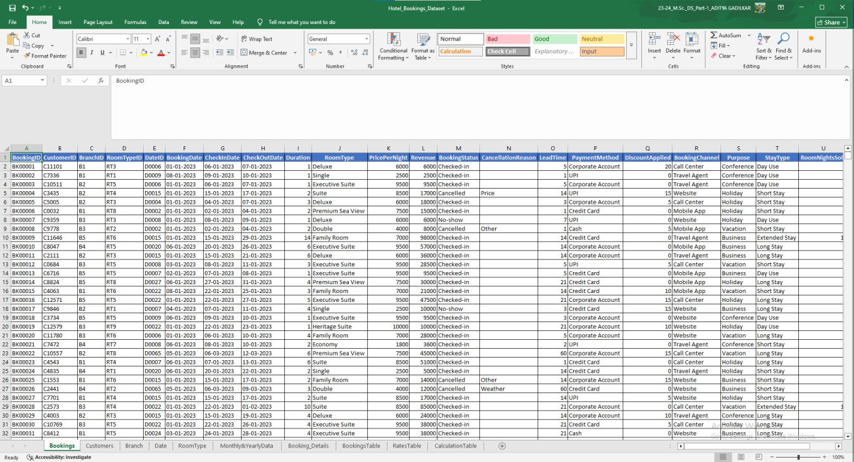

**2. Star Schema**

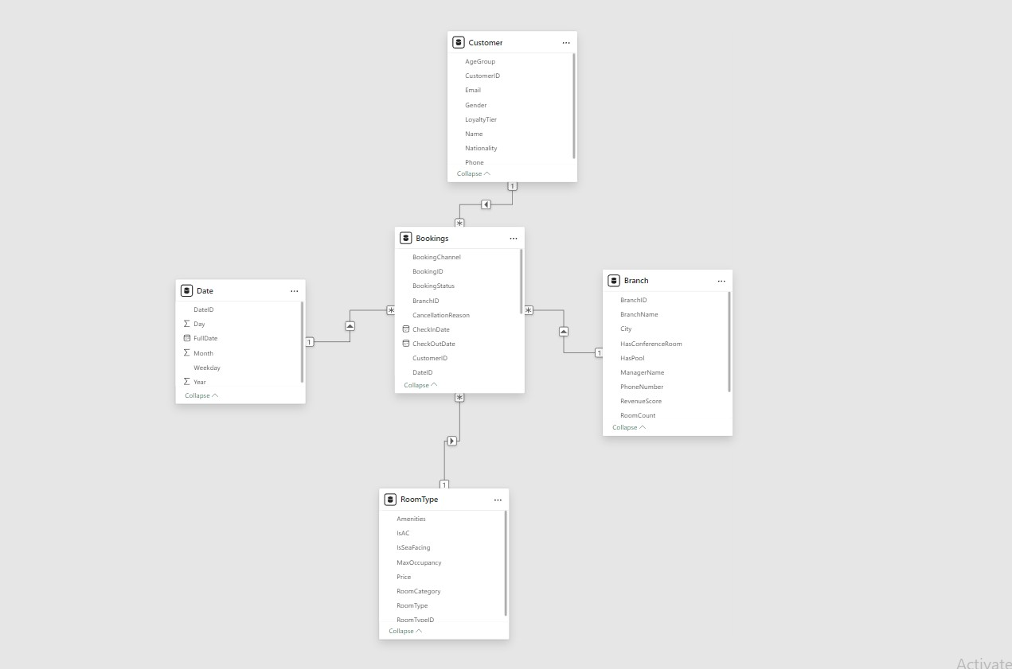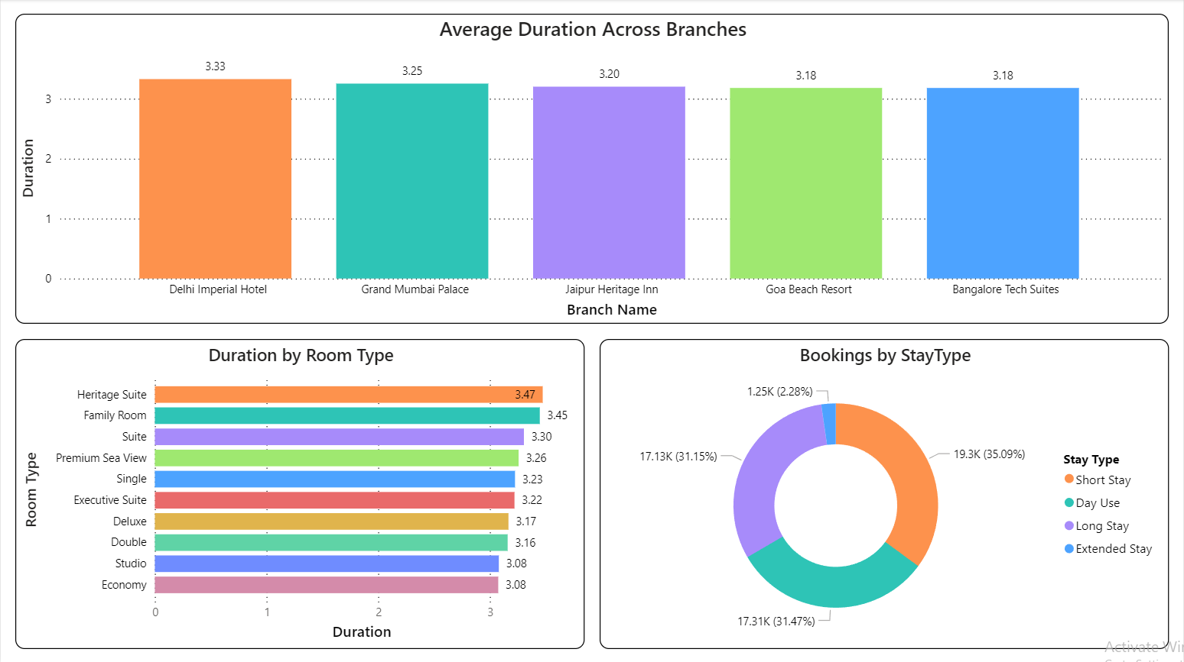

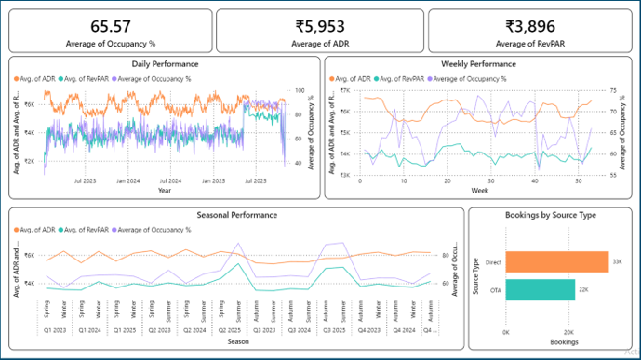

**Module 2 - Occupancy & Revenue Metrics**

**Module 3 - Guest Analysis Module**

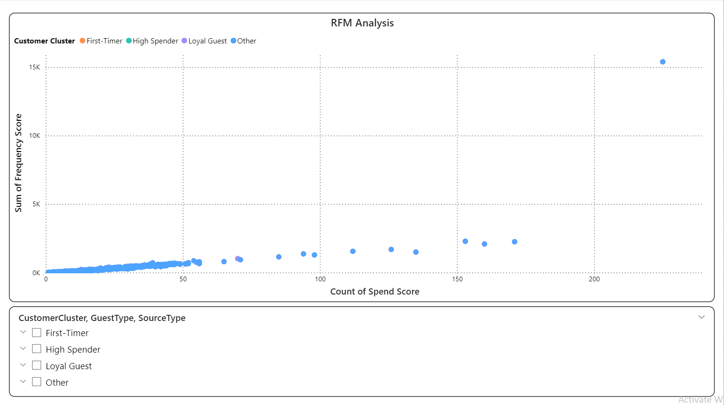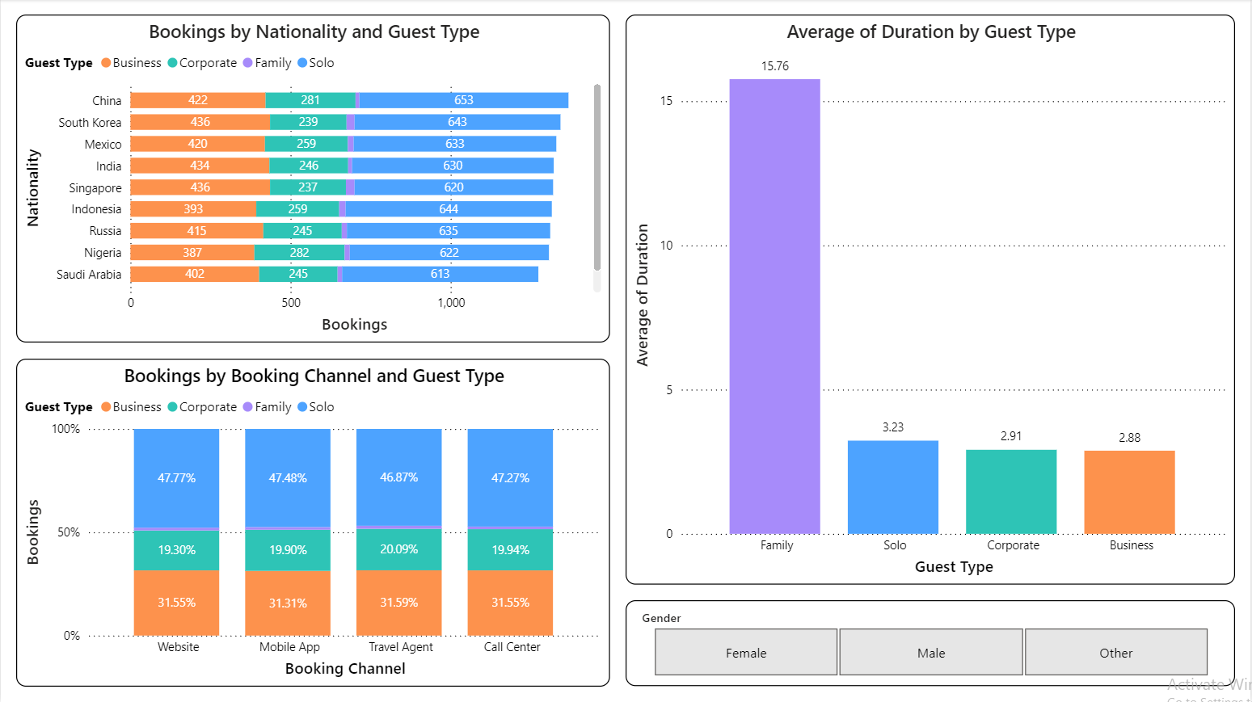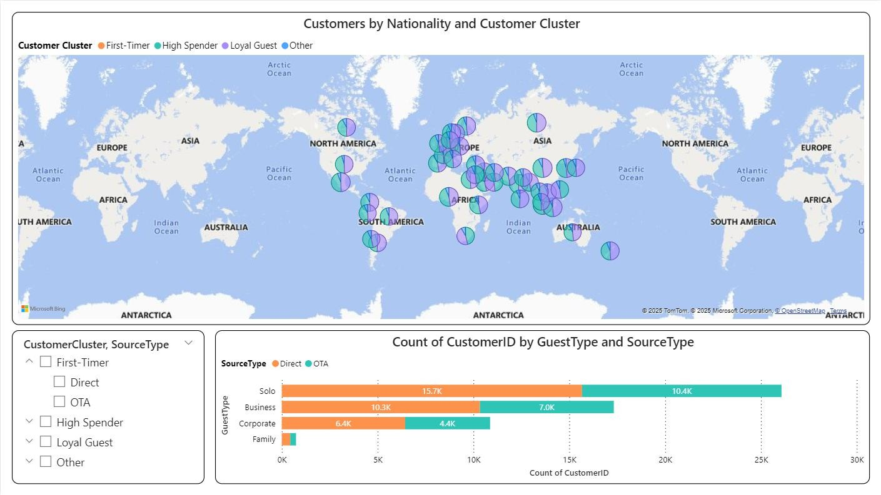

**Module 4 - Forecasting and Cancellation Trends**

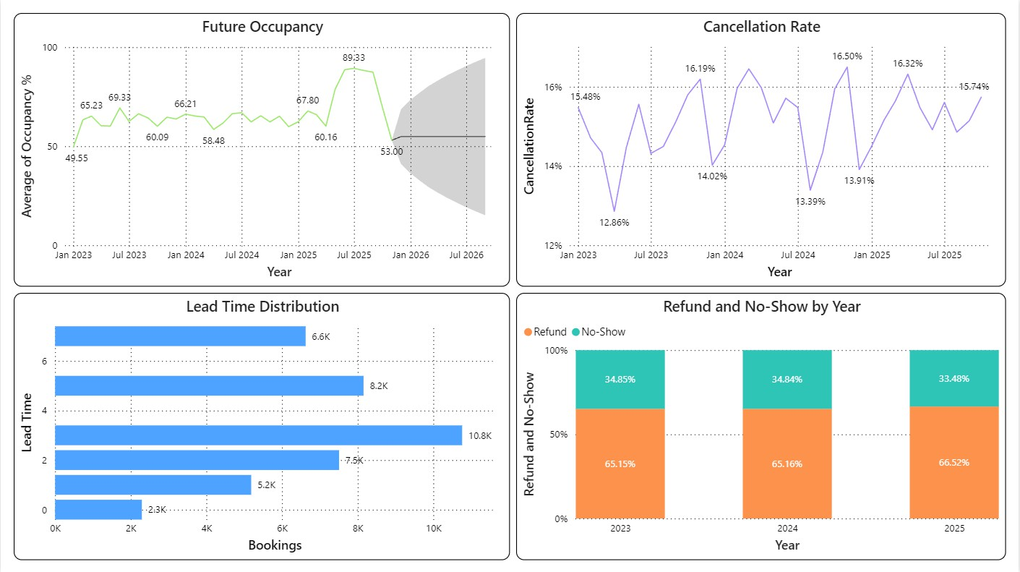

**Module 5 - Revenue Strategy Dashboard**

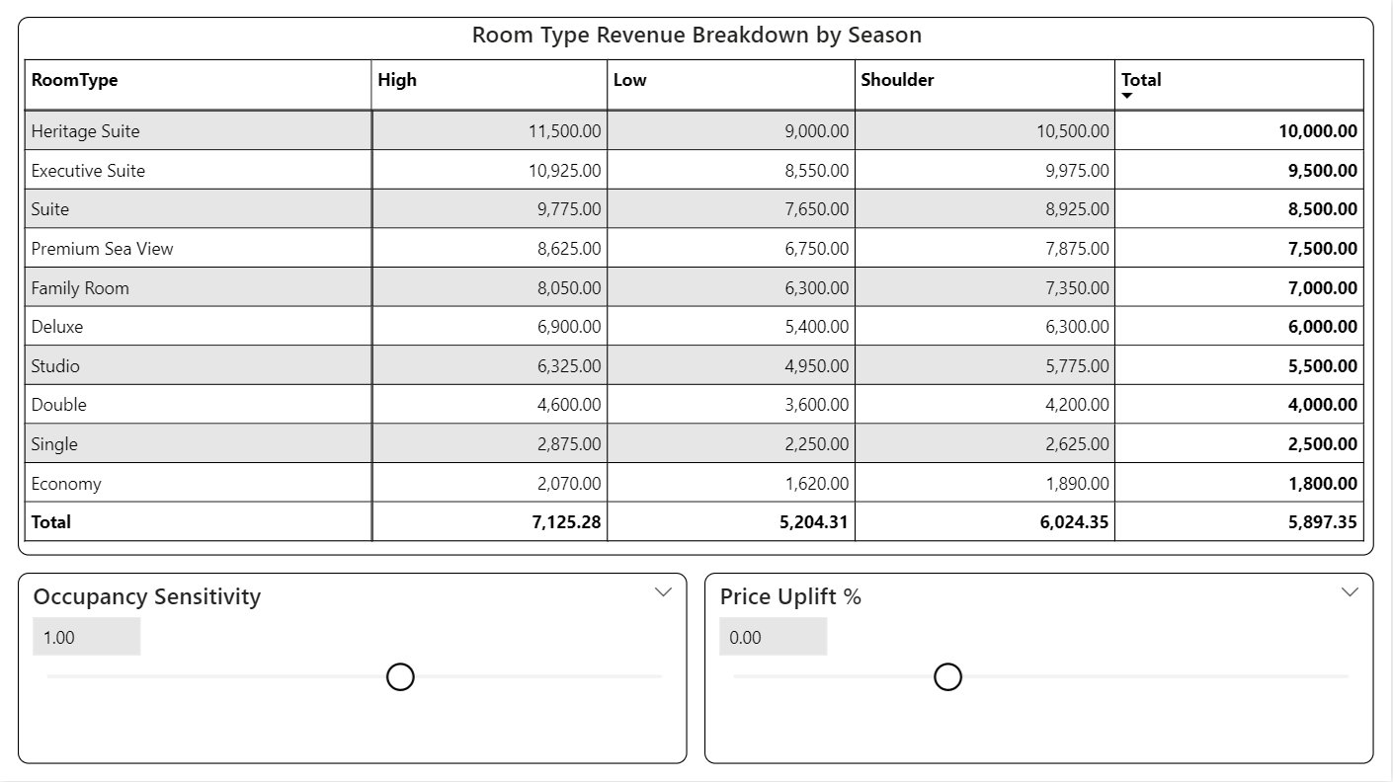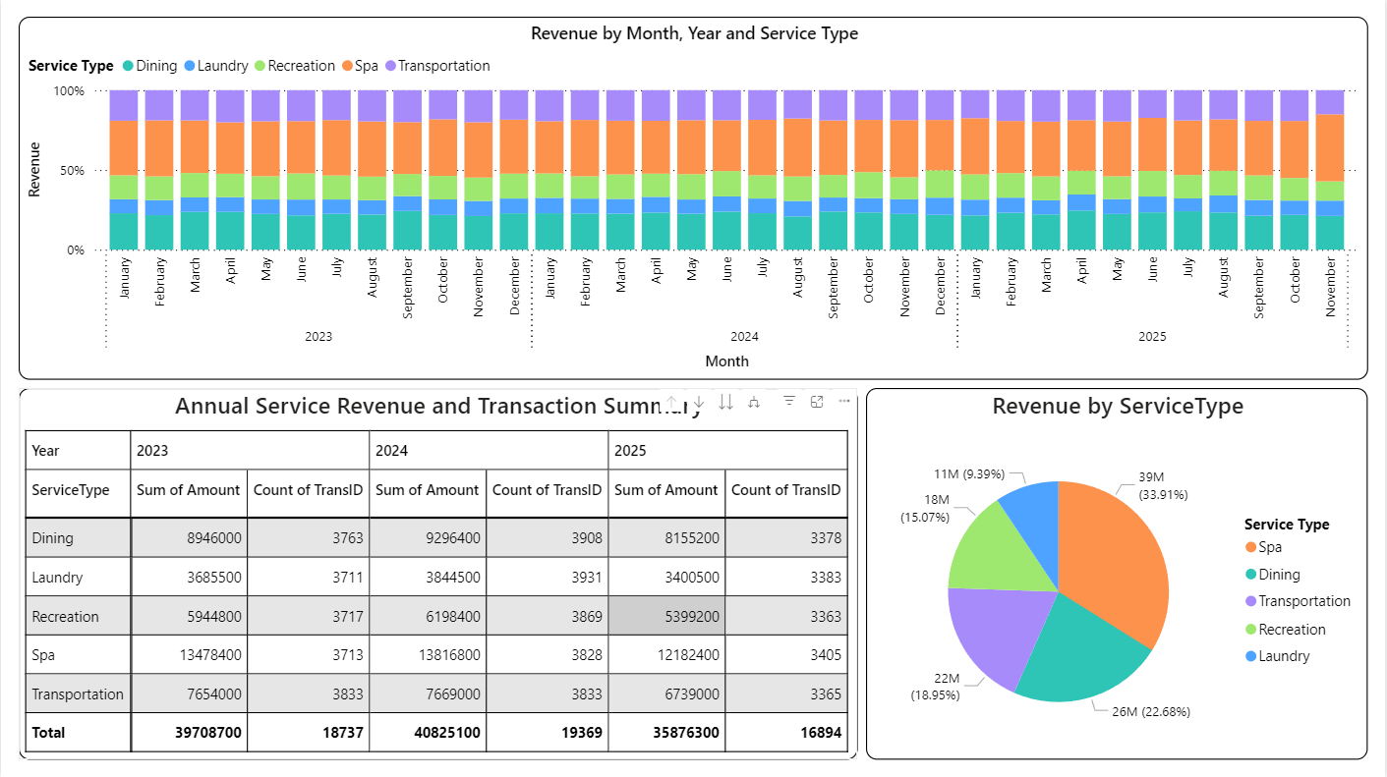

**General Manager (GM) Dashboard**

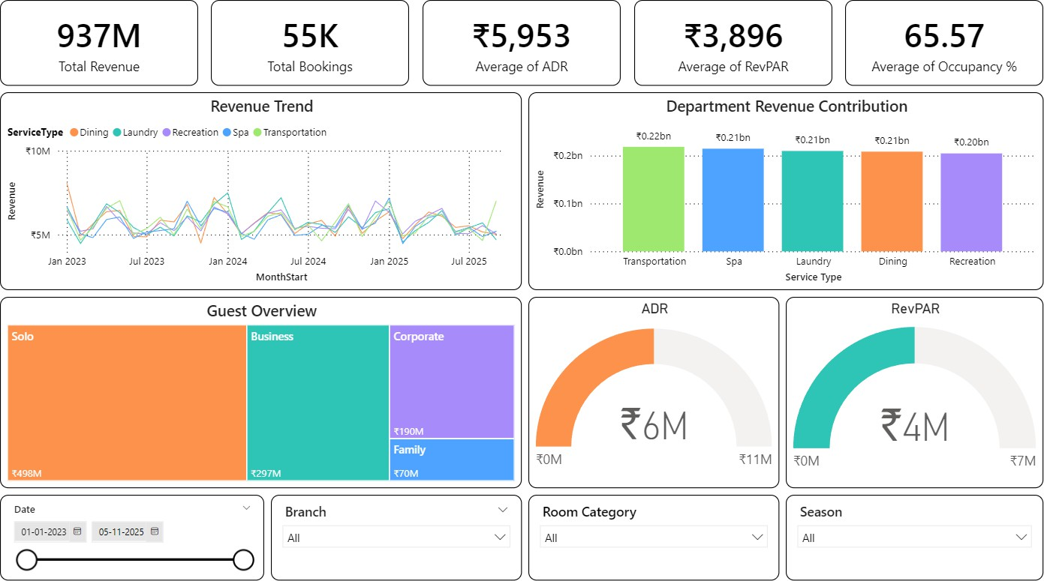

**Revenue Manager (RM) Dashboard**

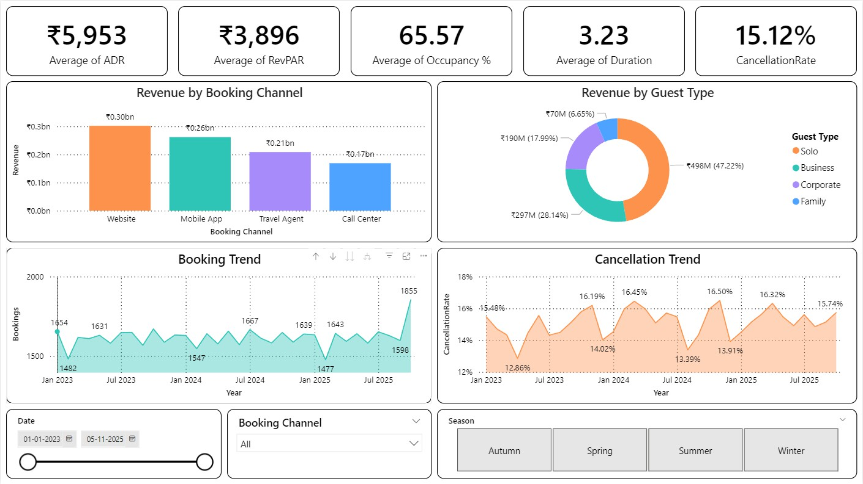

1. **Challenges Faced**

During the development and implementation of the **HotelRevAI – AI-Driven Revenue Analysis for Hotels** project, several technical, analytical, and design-related challenges were encountered. These challenges were systematically addressed to ensure the successful completion of the project.

**Data Quality and Consistency Issues**

Hotel booking datasets contained missing values, inconsistent date formats, and varied representations of booking channels and room categories. Significant effort was required to clean, standardize, and validate the data before analysis.

**Complexity in Data Modeling**

Designing a scalable **star schema** that accurately represented booking facts while supporting multiple dimensions such as date, room type, customer, and hotel branch required careful planning to avoid redundancy and ensure efficient querying.

**Accurate KPI Calculation**

Metrics like Occupancy %, ADR, and RevPAR require precise business logic. Ensuring correct calculations across different time granularities (daily, weekly, seasonal) while avoiding aggregation errors was a major analytical challenge.

**Guest Segmentation and Classification**

Segmenting guests into categories such as business, family, loyal guests, and high spenders involved selecting meaningful features and validating segmentation logic to ensure business relevance.

**Forecasting and Trend Interpretation**

Predicting future occupancy and interpreting cancellation trends required careful handling of historical data patterns and seasonality to avoid misleading forecasts.

**Dashboard Design and Usability**

Creating a single dashboard that balances detailed analytics with clarity for both **General Managers** and **Revenue Managers** was challenging. The dashboard needed to remain interactive, intuitive, and decision-focused without overwhelming users.

**8. Learnings & Skills Acquired**

The **HotelRevAI** project provided extensive hands-on exposure to hospitality analytics, data modeling, and business intelligence tools. The key learnings and skills acquired during the project include:

**Hospitality Domain Knowledge**

Gained a strong understanding of hotel revenue management concepts such as occupancy rate, ADR, RevPAR, booking lead time, and cancellation behavior.

**Data Modeling & ETL Skills**

Learned to design and implement a star schema, handle fact–dimension relationships, and create calculated fields for analytical reporting.

**Data Analysis & KPI Development**

Developed expertise in calculating and validating business KPIs and analyzing trends across time, customer segments, and booking channels.

**Guest Segmentation & Behavioral Analysis**

Acquired skills in customer profiling, segmentation, and clustering to identify loyal guests, high-value customers, and different traveler types.

**Forecasting & Trend Analysis**

Learned to analyze historical booking data to identify demand patterns, seasonal trends, and future occupancy forecasts.

**Dashboard Development & Storytelling**

Improved proficiency in building interactive dashboards using Power BI, applying slicers, drill-downs, and visual storytelling techniques to present insights effectively.

**Analytical Thinking & Decision Support**

Strengthened the ability to translate raw data into actionable insights that support strategic decision- making for hotel management.

**9.Testimonials from Team**

The **HotelRevAI** project team demonstrated strong analytical capabilities, consistent collaboration, and a clear understanding of business-driven data analytics. The project was executed with a structured approach, meeting all planned milestones within the given timeline.

The team showed commendable dedication in understanding hospitality revenue concepts, implementing accurate KPIs, and designing an intuitive dashboard tailored for hotel decision-makers. Their ability to combine technical skills with business insights reflects a high level of professionalism and readiness for real-world analytics challenges.

1. **Conclusion**

The **HotelRevAI – AI-Driven Revenue Analysis for Hotels** project successfully demonstrates the application of data analytics and AI concepts in the hospitality domain. By integrating data modeling, performance metrics, guest analysis, and forecasting into a unified dashboard, the project delivers actionable insights that support strategic revenue management.

The project enhanced practical understanding of hotel KPIs, data visualization, analytical thinking, and business-oriented storytelling. Overall, HotelRevAI serves as a strong foundation for advanced analytics- driven decision support systems in the hospitality industry.

1. **Acknowledgements**

I sincerely thank the mentors, coordinators, and reviewers for their valuable guidance and continuous support throughout the project. Their feedback and direction played a crucial role in the successful completion of this project. I am also grateful for the opportunity to apply analytical and AI concepts to a real-world hospitality use case.